|  |
| --- |
| 新东方在线英语学习 |
| 新概念 2 册 |
| Lesson25 |



扫一扫。更多有趣的英语资讯。

# Lesson 25 单词讲解

1. railway n. 铁路

railway station

1. porter n. 搬运工
2. several quantifier 几个

several times several people

1. foreigner n. 外国人

foreign adj. 外国的，外国人的

a foreign language

TOEFL = Test Of English as a Foreign Language

1. wonder v. 感到奇怪

feel surprised want to know

# Lesson 25 课文&语法讲解

1. I arrived in London … arrive at the airport arrive on the scene at last



in the end

finally eventually

2. I did not know the way to my hotel, so I asked a porter.

句子的分类 （按照结构划分）

* 1. 简单句
  2. 并列句多个简单句 一样重要 有连接词连起来
  3. 复合句

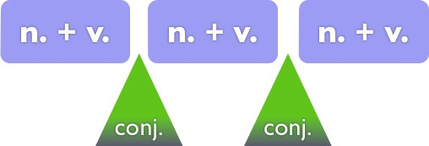

并 列 句 并列连词



并 列 句 并列连词

and but or

并 列 句 并列连词but

yet

It is summer, but it is very cold.

并 列 句 并列连词and

both … and …

not only … but … as well not only … but also … not only … but…

并 列 句 并列连词or

either … or … neither … nor … 并列句



并列连词

I ran to the station. I missed the bus.

I ran to the station but I missed the bus. I ran to the station but missed the bus.

并列句

并列连词

They walked into the room. They sat down. They walked into the room and they sat down. They walked into the room and sat down.

并 列 句 并列连词

She is very beautiful. She is very smart.

She is not only very beautiful but she is very smart as well. She is not only very beautiful but very smart as well.

并 列 句 并列连词

He can not read. He cannot write. He can neither read nor write.

1. I did not know the way …, so I asked a porter.
2. I not only spoke English very carefully, but very clearly as well.
3. I repeated my question …, and … he understood.
4. …, but he spoke neither slowly nor clearly.
5. The he said … and I understood ...
6. The English understand …, but I don’t understand …

# 并列句怎么考？

**Lesson 25 知识拓展**

1. 并列连词（根据上下文语意）
2. 并列句的省略

You have to move out of the way the truck cannot get past you.

* 1. so
  2. or
  3. and
  4. but (2012 课标 全国 34)
* Someone wants you on the phone.
* nobody knows I am here.

1. Although
2. And
3. But
4. So

(2011 课标 全国 25)

Find ways to praise your children often, you’ll find they will open their hearts to you.

A. till



1. or
2. and
3. but (2011 山东 23)

并列句的省略：

I am a teacher and I like English.

I am a teacher and like English.

I am lying in bed and I am reading a book. I am lying in bed and reading a book.

I think Tom, as the head of a big department, should either study regularly or his job.

1. quits
2. to quit
3. quitting
4. quit (2012 浙江 8)

I think Tom, as the head of a big department, should either study regularly or his job.

1. quits
2. to quit
3. quitting
4. quit (2012 浙江 8)

I think Tom, as the head of a big department, should *either* study regularly *or* his job.

1. quits
2. to quit
3. quitting
4. quit (2012 浙江 8)

